EX. NO: 04 Assignment of IP Address manually to computers (LAN)
DATE: 23.07.2026

AIM:
To configure your System and assign an IP address to the Hub:

Algorithm:
- On your PC, navigate to the Ethernet network settings dialog.
- Click the Internet Protocol Version 4 (TCP/IPv4) parameter.

- Click Properties. The Internet Protocol Version 4 (TCP/IPv4) Properties dialog appears.
- Select Use the following IP address.
Note IMPORTANT: Make note of the current IP address entries for IP address, Subnet mask, and Default gateway. You will need this information to complete the final step of the process.
- Configure with the following details:
  - IP address for PC: 192.168.210.2
  - Subnet: 255.255.255.0
  - Gateway: 192.168.210.1

- Click OK.
- Open a browser window.
- Enter the default gateway IP address to access the Hub: 192.168.210.1. The Hub login screen displays.
- Log into the Hub using the default user name and password. The default user name is admin and the default password is printed on the bottom label of the device and on the loose label included in the package. If the defaults to not work, they may have been changed. Confirm this information with your system administrator.
- Update the IP address for the device.
- On your PC, revert the IP address information to the original entries.
- Return to the Internet Protocol Version 4 (TCP/IPv4) Properties dialog.
- Enter the original IP address entries for IP address, Subnet mask, and Default gateway. c. Click OK.

BEFORE CHANGING THE IP ADDRESS:
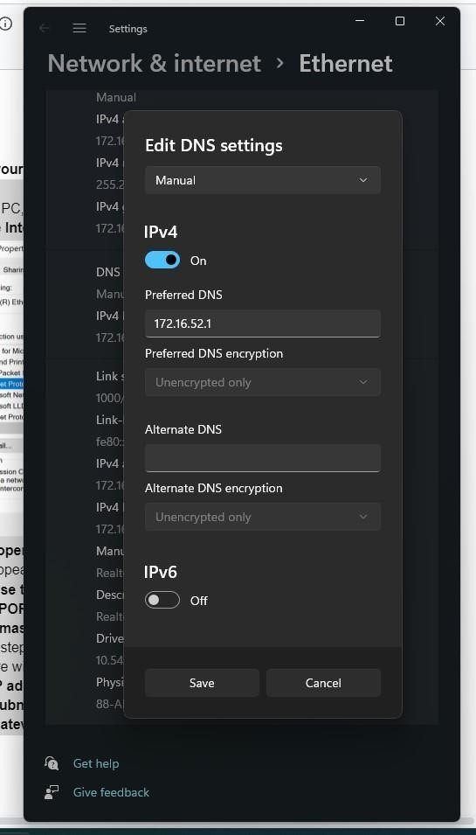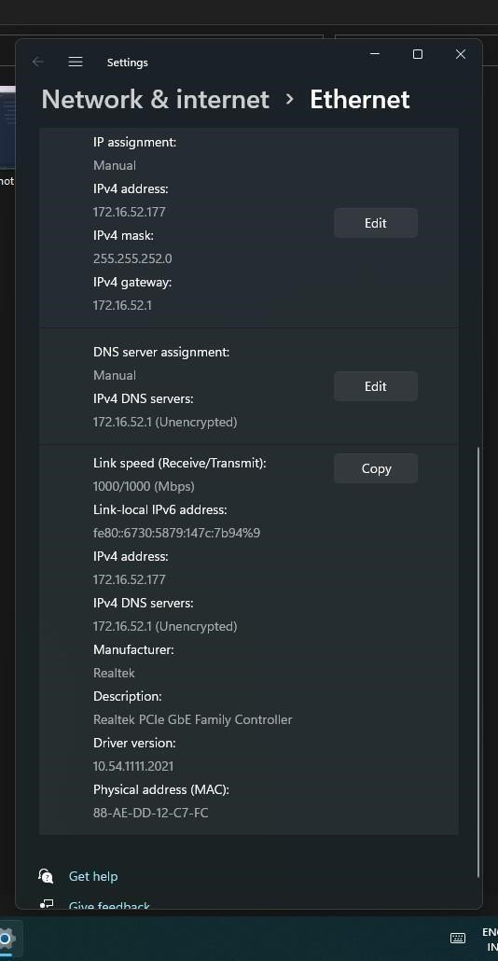

AFTER CHANGING THE IP ADDRESS:
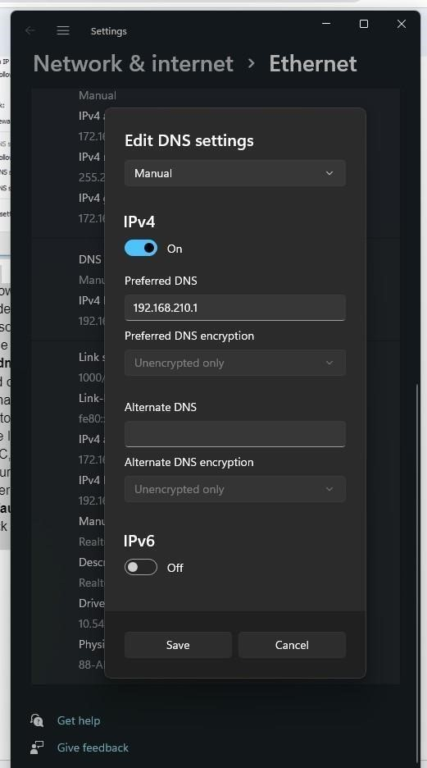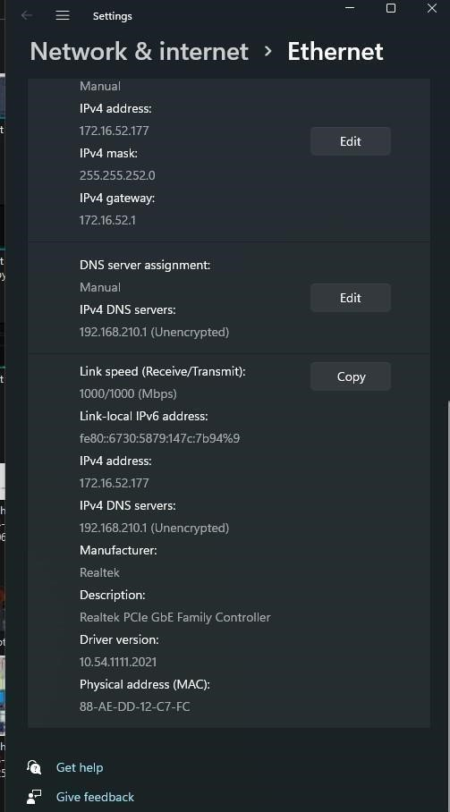

RESULT: your System and assign an IP address to the Hub is configure successfully.

